**Tutorial 11: Template Refs**

Template refs allows us to store a reference to a dot element inside a variable. Then when we have that reference we can use regular JavaScript methods and properties to do things like change classes, text content, styles, etc.

Make sure **Tutorial 10** is complete to be able to move on to this tutorial or clone the [vue3-firebase-course](https://github.com/younggrasshopperza/vue3-firebase-course) repository and go to branch called **Tutorial-10**.

**Step 1:** In the **App.vue** file create an **input field** and give it a **ref** of name. Create a **button** and attach a **click event** to this button called **handle**. Create a function in the methods section called **handle** which will be invoked when the event button is clicked. In the function call the reference name and add a class called active to the element.

Look at the example below (**Between Line 4 to 5 and between line 17 to 20**):

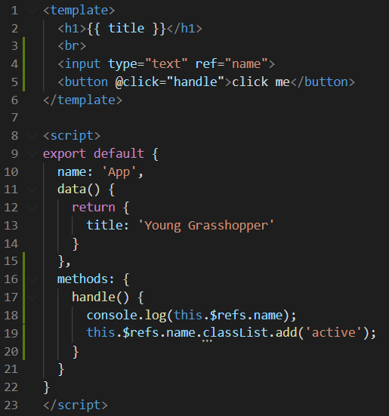

**Output:**

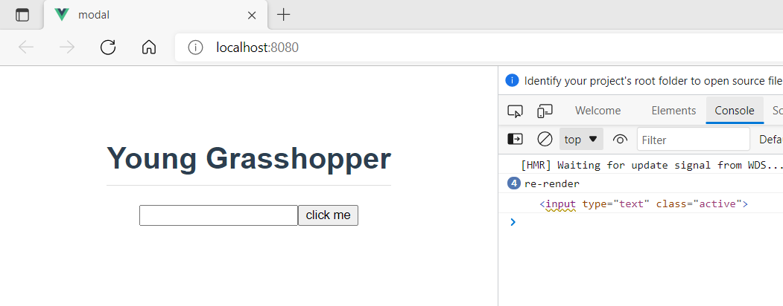

**Step 2:** In the App.vue file inside the handle function focus the name reference and have a look at the output.

Look at the example below (**Line 20**):

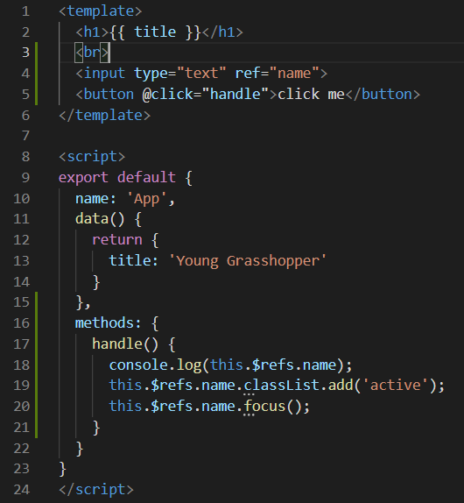

**Output:**

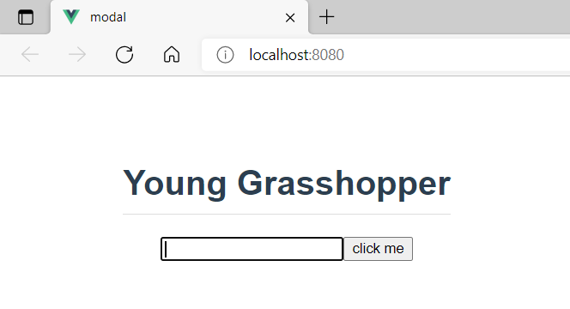

**You can view the code snippets from the** [**vue3-firebase-course**](https://github.com/younggrasshopperza/vue3-firebase-course) **repository under the Tutorial-11 branch.**